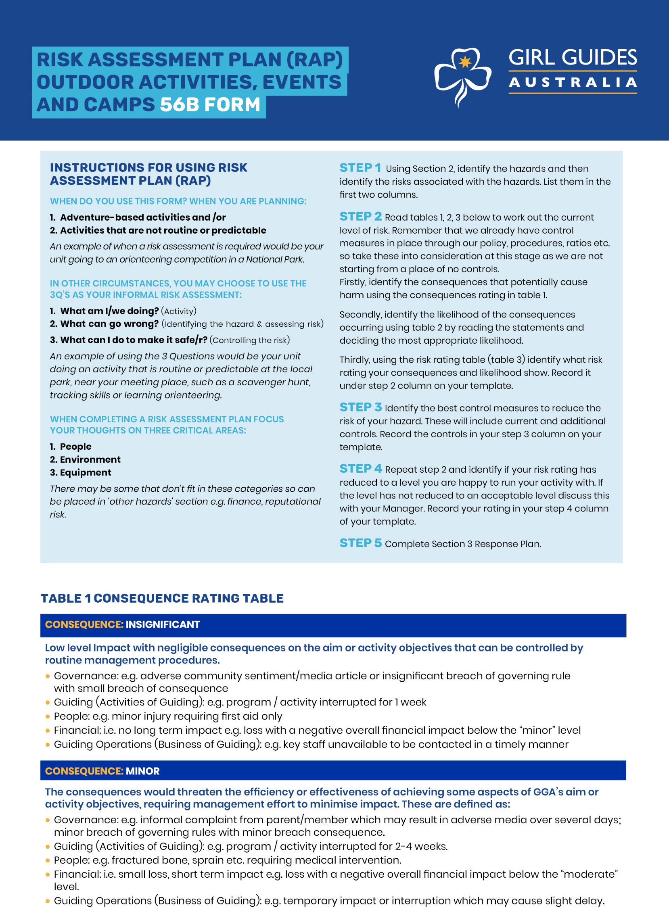

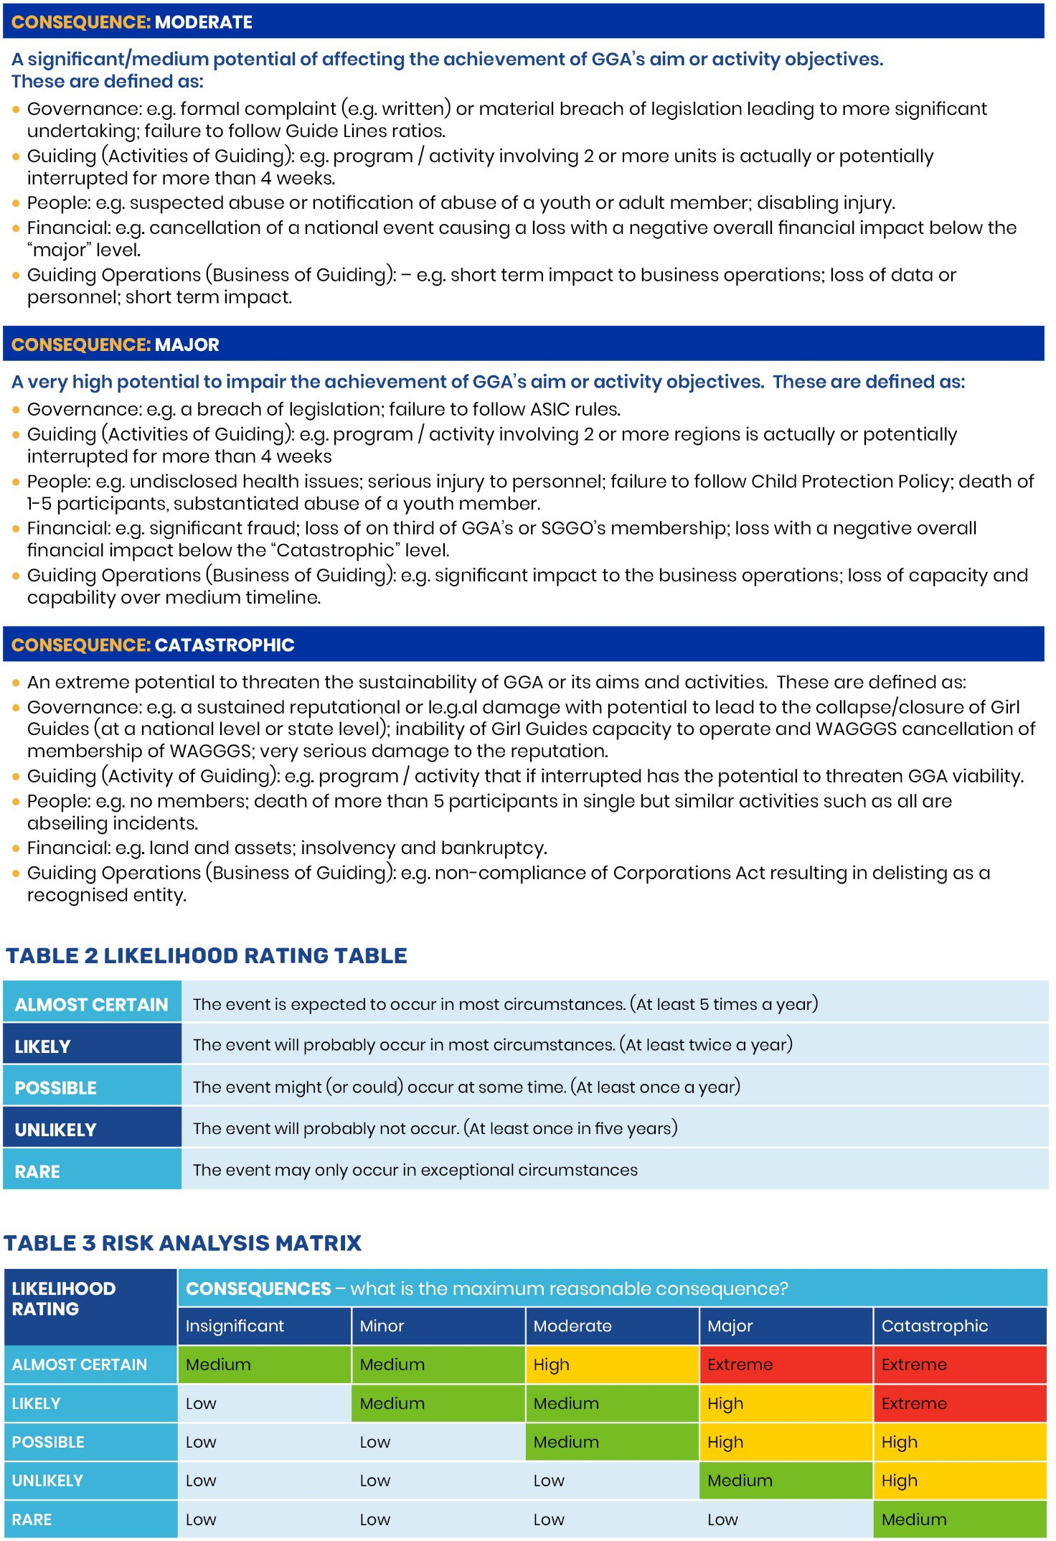

Section 1. Details of Activity requiring Risk Assessment
Activity Type |  |  |  | Outline of activities
Location for activity |  |  |  | Date/s of activity
Unit |  | District/s |  | Region |  | State
Chair of Committee
Leader in Charge |  |  |  | Qualifications of  LiC
First Aider |  |  |  | Qualifications of  First Aider
Aims of activity |  |  |  | Risk assessment  prepared by

Section 2. Risk Assessment
Step 1 Identify the hazards People, Environment, Equipment |  | Step 2 Assess the current risk  See tables 1,2,3 | Step 3 Control the risk | Who & When | Step 4. Reassess the risk Use table 1,2,3 again
Identify the Hazard | What is the harm associated with the hazard? | Is the risk low, medium, high or  extreme? | What controls are already in place and what else needs to be done to reduce or remove  the risk? | By whom? By when? | Now that controls have been put in place reassess  the risk
People Hazards (eg skill, experience, health and fitness, age, fears)

Girl Guides Australia Risk Assessment Plan - August 2021 3 | 5

Environmental Hazards (eg weather, remoteness, terrain, water, shelter)
Identify the Hazard | What is the harm associated with the hazard? | Is the risk low, medium, high or  extreme? | What controls are already in place and what else needs to be done to reduce or remove  the risk? | By whom? By when? | Now that controls have been put in place reassess the risk
Equipment Hazards (eg clothing, kayaks, camping equipment, cars)
Identify the Hazard | What is the harm associated with the hazard? | Is the risk low, medium, high or  extreme? | What controls are already in place and what else needs to be done to reduce or remove  the risk? | By whom? By when? | Now that controls have been put in place reassess the risk
Other hazards (eg finance, reputation)
Identify the Hazard | What is the harm associated with the hazard? | Is the risk low, medium, high or  extreme? | What controls are already in place and what else needs to be done to reduce or remove  the risk? | By whom? By when? | Now that controls have been put in place reassess the risk

Section 3. Response Plan
Evacuation Response Procedures eg. fire, flood
Emergency Response Procedures
What? |  | Equipment? |  |  | Where located?
Onsite Emergency Contacts
Name |  |  |  | Phone Number
Name |  |  |  | Phone Number
Offsite emergency contacts - Phone Numbers
Emergency Services | Police, Ambulance, Fire: 000 |  | Police Link: 13 14 44 |  |  | Poison Hotline: 13 11 26
Local Health services (to the event)
Girl Guides

