

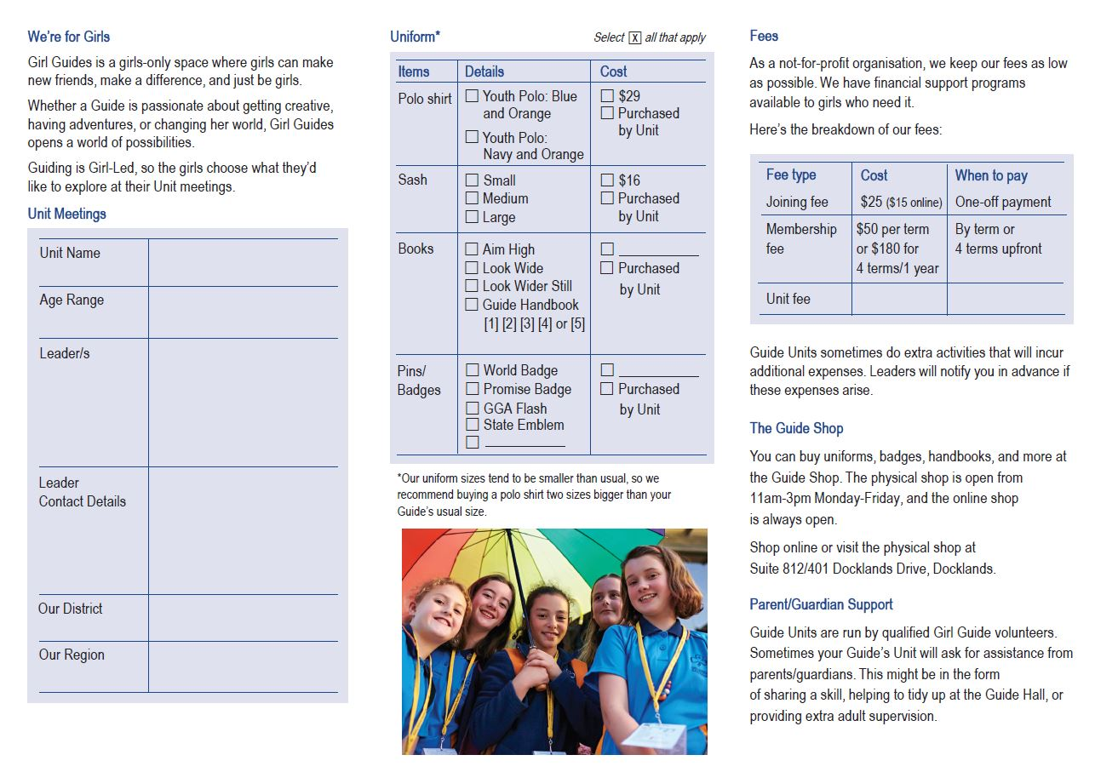

Insert other

Insert cost

Insert cost

Insert when to pay

Insert cost

Insert Region name

Insert District name

Insert phone and/or email

Insert Leader/s name/s

E.g. 5 – 10 years

Insert Unit name