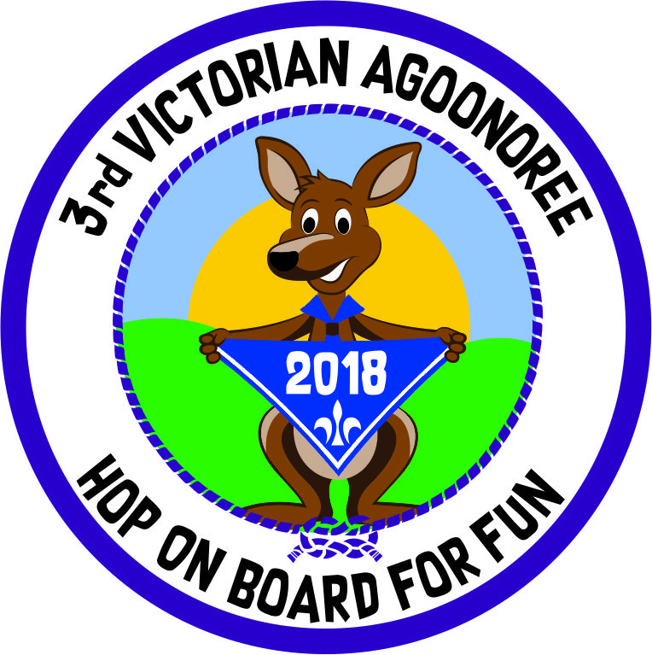 | APPLICATION TO ATTEND THE  3rd VICTORIAN AGOONOREE  “Treetop’s” Scout Camp Riddell’s Creek

[Type a quote from the document or the summary of an interesting point. You can position the text box anywhere in the document. Use the Text Box Tools tab to change the formatting of the pull quote text box.]

May 2018

APPLICATION: Please note there are 3 pages in this Application + separate payment sheet.

I, (print full name in Block Letters)… ……….……………….………… (Applicant)
wish to be considered for selection to attend the 3rd Victorian Agoonoree
I understand and agree to abide by the Scout Promise and Law which I acknowledge is the Code of Conduct for this event.
- As a member of Scouts Australia Victorian Branch, I also agree to accept the conditions and requirements as set by Scouts Australia and the Agoonoree organizers.
- I understand and agree that drugs, alcohol and any other illegal activity as decreed by Scouts Australia are illegal for me as a participant in this event.
- I have signed the Agreement and Authority on this application, and I agree to be bound by the terms and conditions therein.

Signature of Applicant or Guardian: …………………………State: … ……… Membership No:

Applicant Details; Leader ☐ Rover ☐Venturer ☐ Scout ☐ Cub ☐ Guide ☐ Carer ☐Male ☐ Female ☐

Family Name: ………………………….…………………. Given Names: ………………………….………………….

Scouting Name (if applicable): ………………………………………… I like to be called: ………………………….………………….

Date of birth: ……………………..Religion: …………………….

Address: Flat/Unit No: ……..… Street No:……………………. Street/Road: ……………………..

Suburb/Town: ………………………….…………………. … State: Postcode: …... ……….

Postal Address, if different from above

Address: …………………………..……...… Suburb/Town: …………………….………………. State: ……….. Postcode: ……….

Telephone numbers: home (…..….) …………..………….., work (…..….) ..…..……………….., mobile ……..…………………….

Email address (for Agoonoree related correspondence only):

Scout Group: …………District: ………………………….…. Region:

Venturer Unit Name .................................................. Rover Crew Name………………………………………………………….

Brief History of scout experience/ major events attended:

…………………………………………………………………………………………………………………………………………………

Emergency Contact (during Agoonoree)

Family Name: Given Name: Relationship

Address: Flat/Unit No: ……..… Street No: Street/Road:

Suburb/Town: State: Postcode:

Telephone numbers: (home) (mobile)

Applicants Full Name:
Medical Statement (Applicant or Guardian to complete)

Medicare number Line number

Expiry Date ...../......
Private Health Fund Yes ☐ No ☐ Fund Name: …………….……………………Membership No: ……………………
Ambulance Member Yes ☐ No ☐ Included in Health Fund Yes/No Membership No: ……….....…........
____________________________________________________________________________________________________
(A) Immunization: Please provide date of your last tetanus immunization. ☐ Last tetanus (year): ………….
Does the applicant wear a medical alert? Yes ☐ No ☐ Necklace ☐ Bracelet ☐
(B) Does the applicant take any medication regularly? Yes ☐ No☐ If yes, please give details below or on separate sheet.

Drug Dose Why taken? Method of Administration

……………………………………… …………………………………….. ………………………………………………………

……………………………………… …………………………………….. ………………………………………………………
(C) Does the applicant have any allergies? Yes ☐ No ☐ If yes, please give details below or on separate sheet.
☐ 1 *Antibiotics ☐ 2 *Foods ☐ 3 *Food dyes/colourings ☐ 4 *Nuts
☐ 5 *Bandages/Dressings ☐ 6 Bee, Ant or Wasp sting ☐ 7 *Animal Hair ☐ 8 Dust mites
☐ 9 *Drugs (other than antibiotics) ☐ 10 *Other

* Extra information. Please describe symptoms of allergic reaction AND treatment protocol:

………………………………………………………………………………………………………………………………………………

………………………………………………………………………………………………………………………………………………
D) Does the applicant have any special dietary requirements? Yes ☐ No ☐ If yes, please give details below
☐ 1 Coeliac (wheat/Gluten free) ☐ 2 Diabetic ☐3 Low Cholesterol/fat ☐ 4 Lactose intolerant
☐ 5 Vegan ☐ 6 Vegetarian ☐ 7 Kosher ☐ 8 Halal ☐ 9 *Other Religious or Cultural
☐ 10 *Other Health (must have doctors letter attached) ☐ 11 *Specific Food allergies (Nuts, Eggs, dairy etc)

* Extra information …………………………………………………………………………………………………………………………..

(E) The details related to any Medical, Physical, Intellectual or Behavioural condition must be supplied to the Leader who will be supervising you during the Agoonoree. However, if you have any of the highlighted conditions you must
complete this form and give as many details as possible of the protocols staff must follow if such a condition occurs.
☐ 1 Heart Trouble ☐ 2 Angina ☐ 3 Blood Pressure/Stroke ☐ 4 Bleeding disorder

☐ 5 Epilepsy/Blackouts ☐ 6 Diabetes ☐ 7 Asthma ☐ 8 Bronchitis

☐ 9 Hay Fever ☐ 10 Migraine ☐11 Back problems ☐ 12 Arthritis

☐13 Urinary Problems ☐ 14 Bed wetting ☐15 Visual impairment ☐ 16 Hearing Impairment/Deaf

☐ 17 Physical disability… .☐ 18 Intellectual impairment ☐ 19 Autism or Asperger’s Syndrome

☐ 20 ADD or ADHD ☐21 Violent behavior towards others or self harm ☐22 Travel sickness

☐23 Medical Aids – Do you use any medical aids Yes ☐ (Please give details) No ☐ ☐24 Other

Extra information…………………………………………………………………………………………………………………………..

………………………………………………………………………………………………………………………………………………..

Signature of Applicant or Guardian …………………………….……………………………………………. Date: …………………….
************ PLEASE PHOTOCOPY THIS MEDICAL STATEMENT FOR YOUR FUTURE REFERENCE ***************

AGREEMENT, ACTIVITIES AND AUTHORITY:
To be completed by Applicant or Guardian

Applicants name: ……………………………………………………………………………………………………………….

In consideration of Scouts Australia accepting this application for the Agoonoree.

I ………………………………………………………………………………..………………………. (Being the above named Applicant)

- ..acknowledge that some of the activities conducted at the Agoonoree may involve physical tasks which inherently contain risk of injury. I understand that those activities are carried out on a choice basis, and that I may decline to participate in any one or more activities.

- ..agree that in the event of accident or illness, I authorize an officer, servant, agent or leader of Scouts Australia to obtain on my behalf, and at my expense, such urgent medical or dental assistance, treatment, nursing, hospital and/or ambulance service as may be considered appropriate by such officer, servant, agent or leader of Scouts Australia, and (should it be advised by a duly qualified medical practitioner that it is necessary) to authorize a general anesthetic.

- ..agree to pay on demand to Scouts Australia, all such medical, hospital and other fees and expenses incurred or to be incurred by Scouts Australia in such circumstances other than such fees recoverable under any policy of insurance taken out by Scouts Australia.

- ..understand that I am expected to act and behave in accordance with the acknowledged principals and rules of Scouts Australia. Should the Agoonoree Chief or the Agoonoree coordinator determine that I have not acted or behaved in such manner, I understand and agree that, at the discretion of the Camp Chief or the Coordinator, I may be returned home by the most direct means at my expense and no claim can or will be made by me for any compensation or damages.

- I agree to pay the Agoonoree fee according to the schedule and a cheque is attached/ an automatic transfer for the full amount has been paid.

- The medical statement has been completed correctly to the best of my knowledge. I acknowledge that I am alone responsible for any problems that may occur due to my failure to disclose any information related to my Medical, Physical, Intellectual or Behavioral condition. I acknowledge that if any aspect of my condition changes from the information provided, in any way, before the Agoonoree, it is my obligation to advise the Agoonoree coordinator, in writing, of such a change.

- I acknowledge the existence of the authority within this application form that it has been drawn to my attention and that I have read and understand the nature and effect of the authority and I agree to abide by the above statement of agreement and authority.

- I acknowledge the information contained in this form will be used exclusively by Scouts Australia for the purpose of the Agoonoree and that the privacy policy of Scouts Australia at www.scoutsvictoria.com.au (About us Policies) applies.

- I acknowledge the four main Safety rules and will abide by all the rules of the Agoonoree as explained to me.

The four main safety rules;
- Stay away from all dams unless supervised by an adult (see Pirate activity).
- Do not take shelter under any tree – head for a building if there is a storm.
- Remember that Kangaroos are wild animals, admire them but don’t go too close.
- In case of emergencies, the Assembly area is the car park area.

…………………………………………………………………. ..……………………………………………………
Signature of Applicant Date

Or I have read every page of this application to the applicant and believe they acknowledge, to the best of their abilities, their responsibilities for this event.

………………………………………………………………….. ……………………………………………………..
Signature of Guardian Date
Other Notes:
It is the responsibility of the Applicant to bring to the Agoonoree all personal gear including all necessary equipment for their health & welfare.

Equipment such as electrical leads and in some cases folding camp beds can be supplied but must be indicated on this form. Please complete the “Special Request” section. A variety of different ramps will be supplied by the Tende beck Scout Group.

This is a camp not a hospital, hotel or specialist School. Roads are good but they are not made. Most activities are outside although some have shelters. The Leader/Youth Member ratio at this event is expected to be 2 Leaders: 1 Youth Member, with the main responsibility of care resting with the designated carer/companion/helper working with each participant with special needs.

List Special requests here.

…………………………………………………………………………………………………………………………………………………

…………………………………………………………………………………………………………………………………………………..

