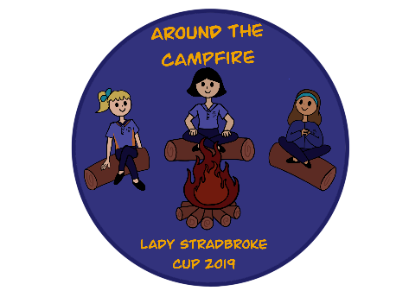
Patrol Registration Form
One form per Patrol
Please ensure all your Patrol members and Unit Leader register online by 11.59 pm on Monday 9 September. This form must be returned by email or via the online form with your Patrol equipment hire form by Friday 20 September 2019.
Remember to give yourself a Patrol name which fits with our theme of ‘Around the Campfire’ – maybe your favourite campfire song! Patrol names will be allocated on a first in best dressed basis and if there is a double up, part of your Unit name will be added.

Patrol Name: | Unit Leader attending:  Please Note: It is a requirement that for every Patrol registered there needs to be one Leader or Unit Helper attending for the full duration of the event to assist with activities and assessments.
Patrol Leader’s name:
Age group of Patrol:
10-14yr old patrol 14-17yr old patrol
Guide Unit Name and District: | Additional Leader or Unit Helper attending:

We will use the information you provide to place you in a category of patrols with a similar level of experience and let you know your category in a mailout approximately one-two weeks out from the event.

 | Guide’s name | Age  As of 25th Oct 2019 | Member  ID Number | Camping experience with Guides
 |  |  |  | Nights slept in a tent where you have also cooked your food and learnt camp skills etc. | Nights slept in a tent  at state camps, Sydney Jamboree or similar where you have had most food/campsite prepared for you
PL
APL
Send the Patrol Registration and Equipment Hire Form to Girl Guides Victoria
by Friday 20 September 2019 or as soon as Patrols are known.

By email: ladystradbrokecup@guidesvic.org.au

Patrol Equipment Hire Form
One form per Patrol
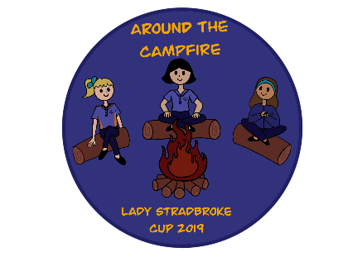
This list must be returned by email or via online form with your Patrol registration form to Girl Guides Victoria by Friday 20 September 2019. Please return this form even if no equipment is ordered to ensure we have a record.
Late requests will not be accommodated. We will do our best to accommodate all requests submitted on time. We will contact your Patrol to confirm your equipment requests after the closing date.

Patrol Name: | Unit Name:

In our experience it is easier to put up tents and work with equipment that you are familiar, with so please keep that in mind when ordering. There are limited supplies at Britannia Park so please indicate if you are ordering any gear which you have access to in your area and can transport to and from camp if some items are in limited supply.

Please check the camp booklet to make sure you have organised to bring or request all the items you need.
Make sure you bring your own:
- Personal gear and bedding as per the kit list
- Gas or butane stove (must be used for Sunday breakfast and may be required in case of wet weather for Saturday dinner). Please read the gas safety information in the event information booklet for details on the requirements around using gas/butane at Lady Stradbroke Cup.
- Food and boxes/eskies to keep it cold and animal safe
- Cooking utensils (pots, billies, mixing bowls, knives, chopping boards etc) – depends on your menu
- Patrol first aid kit AND personal first aid kits
- Cleaning requirements
- Gadget wood and rope etc.
- Lighting for your site
- Tarp to cover your wood pile
- Hessian/sacks for fire buckets
- Plastic bowls for hand washing/dishwashing
- Sufficient firewood to cook your Saturday dinner

Item | Qty requested | We’d like one, but if needed we could BYO...
ACE sleeping dome tent (sleeps 6 plus gear comfortably)
Cork tent (can be used as a kitchen shelter)
Fire drum (limited supply – please BYO if possible)
Grill for fire drum (limited supply – please BYO if possible)
Fire bucket (max 2 per patrol) – BYO Hessian
Mallets (max 2 per patrol)
Trestle tables (max 2 per patrol) (limited supply – please BYO if possible)
‘Uprights’ (wooden poles used to lift boxes etc off ground) (max 2)
Large cooking pot (max 1 per patrol)

For any equipment questions, please contact ladystradbrokecup@guidesvic.org.au

