GIRL GUIDES VICTORIA
GIPPSLAND REGION
BURNET PARK CAMPSITE

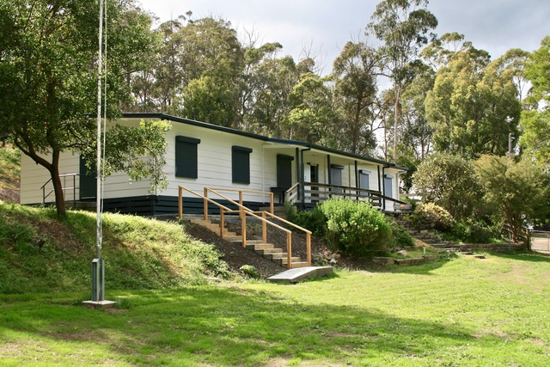

Guide Camp Rd, Glengarry West
Description
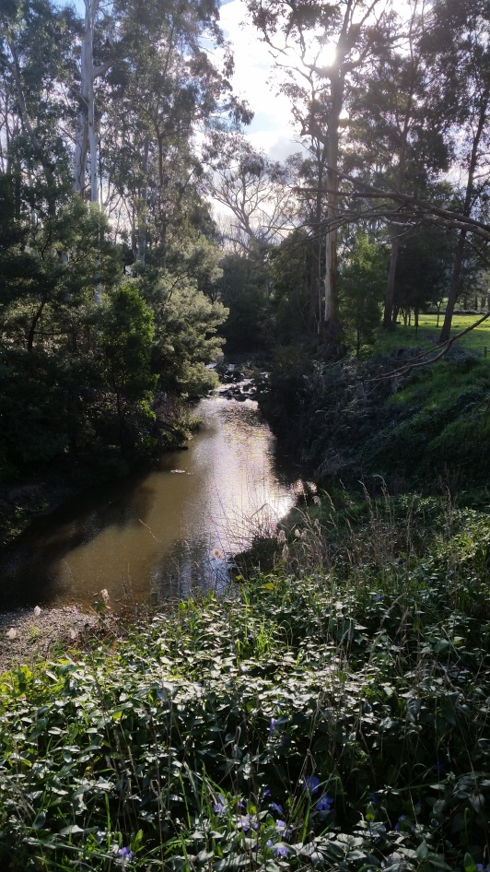
Burnet Park is a small rural campsite, 178km from Melbourne CBD. The bunkhouse, called Illangi sleeps 20 persons and has a kitchen, dining/activity room and two bathrooms, one of which is disabled accessible. The outdoor area has an equipment shed and garden shed which contain tents and other camping equipment. There are two drop toilets for the use of outdoor campers. Some wood for fires and hot water copper is available. The outdoor area is fenced off from Rintouls Creek which runs beside the camp ground. The whole area is surrounded by peaceful farmland, and wildlife, such as wombats and kangaroos, are frequent visitors.
Rintouls Creek

Activities On Site
Burnet Park is the ideal location to develop the basic Girl Guide camping skills. Cooking can be done on an open fire or gas. The area is large enough to develop wide games and there are plenty of sticks etc. to use for making gadgets. The campfire area is ideal for traditional Girl Guide campfires or just a casual area to sit and talk at night.
The surrounding bush and Rintouls Creek allow for environmental activities. “Ponding” can be done in the creek and there are a variety of native plants, animals and birds to be identified.
The outdoor chapel provides the ideal location for Guides Own.

The surrounding area
Lake Narracan is nearby for boating activities.
Walhalla makes for a fascinating local visit to learn about mining and the early pioneers.
Morwell National Park and the Baw Baw plateau are also within reach of Burnet Park.
Wirilda Environment Park is just past Tyers and a lovely place to explore and picnic.
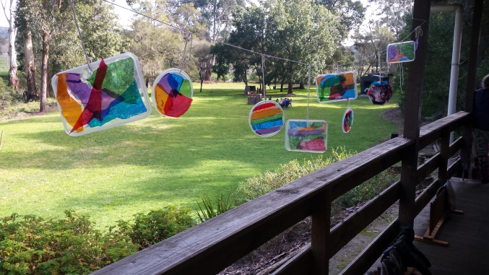
Contact
http://www.guidesvic.org.au/GG/Venues/BurnetPark
or
Booking Secretary
Dorothy Sturgess
burnetparkbookings@gmail.com

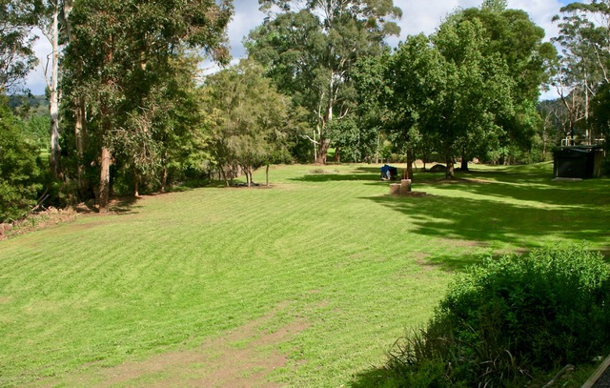

BP 501 Rev D: 02/11/2020

